STX-26 Stump Grinder - 26hp (19.4kw)
- Easy-to-use controls
- Fits easily through standard 36" (91 cm) gates
- Track drive increases hill-side stability
- Toro exclusive traction control system similar to Dingo TX and TRX trenchers
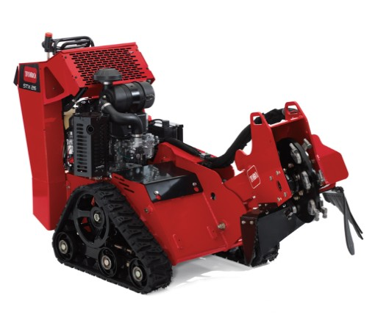
- Overview
- Features
- Specifications
- Manuals
- Images & Video

Some dedicated stump grinders are over-complicated. Not the Toro STX. Its patented Toro® Dingo® TX-style control system has two simple levers that are simple to learn, master and use. Combine these easy-to-use controls with tracks and transport speeds exceeding 4 mph, and you get maximum productivity. Wet, hilly terrain won't stop you from accessing tough jobs year-round with an STX stump grinder. The tracks travel easily over muddy areas, with the low center of gravity adds side hill stability. In addition, the hydraulically driven head means no chance of expensive belts breaking or slipping no adjusting tension - guaranteeing optimal performs time after time.

Track Design
• Allows for zero turn capability
• Provides a low center of gravity and large footprint
• Increased stability on side hills
• Eliminates tire ruts and flat tires
• Operates in wet & soft ground conditions.
• Get to the most challenging stumps

Traction Controls
Easy-to-use control system offers smooth operation and fewer lever/nobs than conventional stump grinders. Two simple controls operate all traction and grinder functions.
1) Left/right traction control (forward, reverse, turn)
2) Sweep, lift/lower and engagement of grinder head.

Full Hydraulic Operation
• Eliminate the labor of tightening or replacing expensive poly-chain® belts or clutches
• No need to replace expensive cogged pulleys
• No worry of customers engaging grinder head at full throttle
• Eliminate shock loads to the engine by belts slipping or head stopping

Offset Cutting Head
• Provides operator with excellent visibility to stump
• Allows full rotation perpendicular to machine

Custom Trailer
Easy to load on any trailer, including Toro's custom TRX trailer with an easy-to-use, built-in securing system. No need for straps or tie-downs. Tailgate design is safer and makes it easier to load than tilt-bed trailers. Trailer features highway rated tires.

Cutting Depth | 12.5" below grade
Cutting Height | 35" above grade
Cutting Wheel | 19" diameter to tooth; 3/4" thick, 12 green teeth
Dimensions | 34" (86.4 cm) W x 78" (198.1 cm) L x 48" (121.9 cm) H
Engine | Kawasaki 730V Twin Cylinder
Head Swing | 47" Arc
Hydraulic Flow | 13.5 gpm hydraulic flow to head
Weight | 1200 lbs. (545 kg)

